PRACTICAL DBMS
NAME: SIDDHI SRIVASTAVA. P
REG.NO:192521454
COURSE CODE: CSA0503
COURSE NAME: DATABASE MANAGEMENT SYSTEMS

EXPERIMENT NO:3 DML Commands – INSERT, SELECT
AIM:
To perform Data Manipulation Language (DML) Commands such as INSERT, SELECT in the table.
Description:
Data Manipulation Language (DML) statements are used for managing data within schema objects. DML
Commands: Insert, Select
➢ INSERT - insert data into a table
➢ SELECT - retrieve data from the a database
INSERT:
INSERT INTO table_name
VALUES (value1, value2, value3,...);
( or )
INSERT INTO table_name (column1, column2, column3,...)
VALUES (value1, value2, value3,...);
SELECT:
SELECT column_name(s)
FROM table_name;
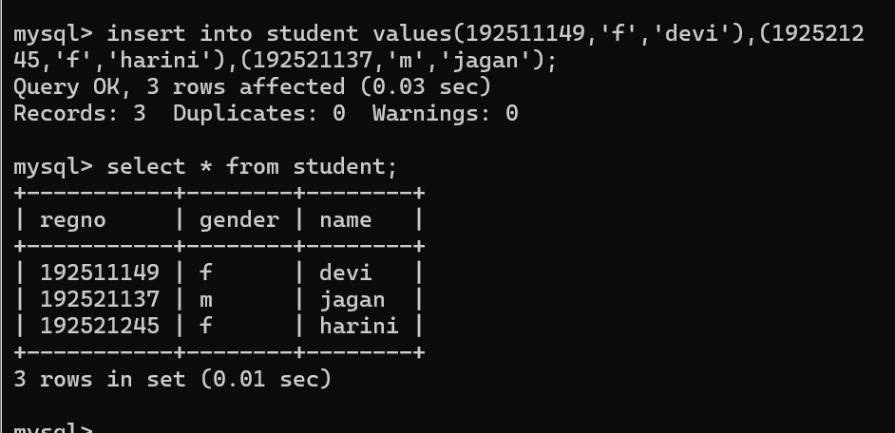

RESULT:
Data Manipulation Language (DML) Commands such as INSERT, SELECT are performed in the five tables.

